- Pick any two food delivery apps you use (like Zomato and Swiggy). Identify one main keyword each that you think users search to find them on Google, and explain why you chose those keywords.
Food Delivery App | Main Keyword | Why I Chose It
Zomato | Zomato food delivery | Users searching this keyword are likely looking to order food through Zomato. It directly describes the app's main service.
Swiggy | Swiggy food delivery | This keyword clearly matches Swiggy's core service and can attract users who want to order food online.

- Use the Ahrefs free Keyword Generator tool to find at least 5 keywords related to 'online movie tickets' (think BookMyShow). List the keywords along with their search volume as shown by the tool.
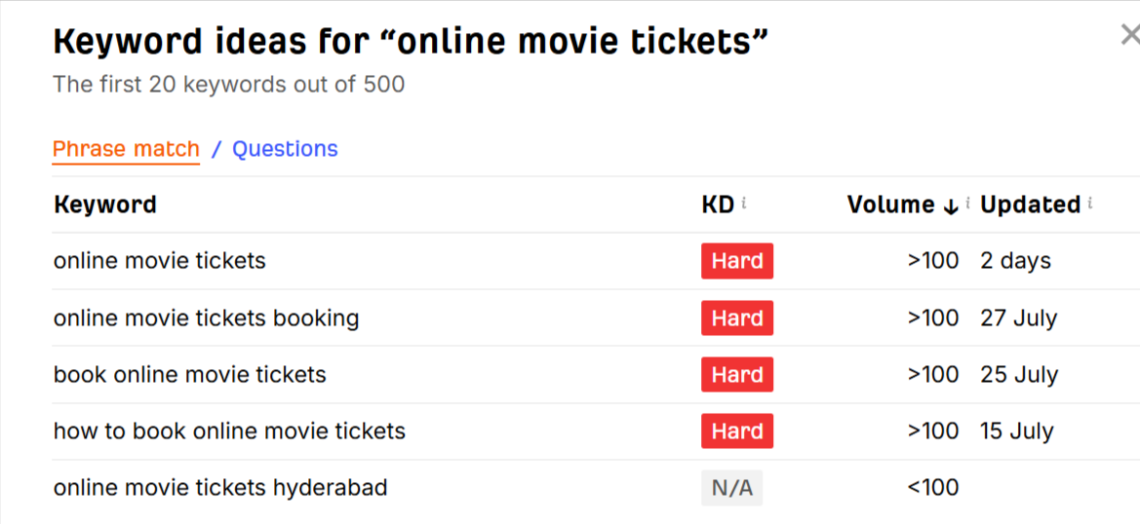
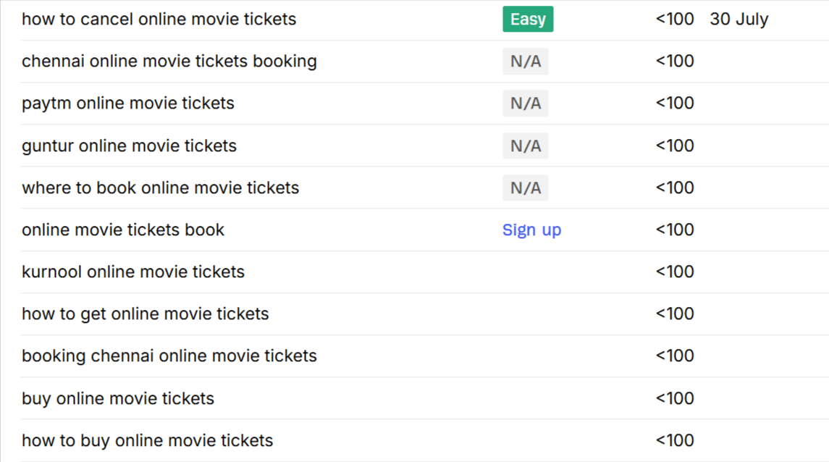

- Go to SEMrush's free Keyword Gap tool and compare two e-commerce sites (for example, Flipkart vs Myntra). Identify 3 keywords that Flipkart ranks for but Myntra does not, and write them down.
